
February 2017
District 26-M2
Volume 35 Issue 4
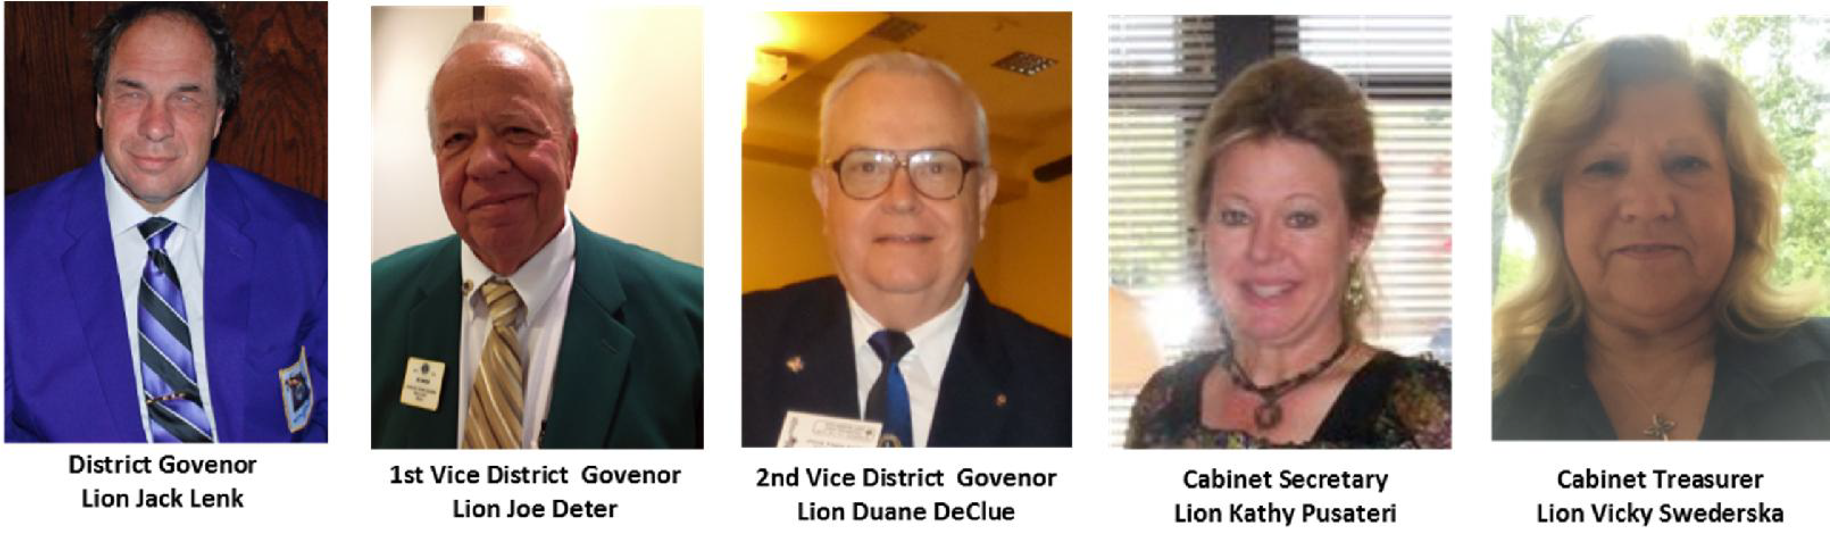
From DG Jack Lenk
Hello, fellow Lions.
All is in readiness for the District Convention to be held March 24-26 at the Doubletree Westport. Friday night’s hospitality will be at the hotel, so we don’t have to go to and from another venue. Come and share a fun and informative time with your brothers and sisters of the emblem.

We have just a handful of clubs to visit. I am pleased and impressed with the efforts of the clubs and the leadership of the District. I encourage all of you to keep up the good work and thank you for your service.

JUST ASK ONE JUST KEEP ONE.
Lion Jack Lenk, District Governor

Missouri Lions shared Lions Clubs International Convention's post.
THIS JUST IN!!!!...
Many Lions are taking the Amtrak to Chicago. Want to save some money? When booking, use the discount code X97C- 959.
Oh yeah!
From 2VDG Lion Duane DeClue
Lion Sandy and I would like to wish everyone a Happy St. Pat's Day and success with our District Float in the St. Louis St. Patrick's Day Parade on March 11, 2017. I was surprised with the presentation at our February Cabinet Meeting of the International Leadership Award by our Governor, Lion Jack Lenk, after nomination by CC Lion Joe Foster.
Thank you for this honor!
Our reorganization of the Lions Clubs in the Festus-Crystal City-Herculaneum Area and Arnold are proceeding. Our Tri- City meeting is February 16, 2017 at the American Legion Post, 849 American Legion Drive, Festus at 7pm. If you have friends or relatives in this Tri-City area please contact them regarding the club. Contacts are being made in Arnold. If you have friends in the Arnold area, let us know so we can discuss Lionism with them. Lion Duane DeClue, 2VDG



CELEBRATE ST. PATRICK’S DAY AND OUR CENTENNIAL YEAR!
SATURDAY, MARCH 11TH, 2017!

You can help show St. Louis the greatness of Lionism by participating in the St. Patrick’s Day parade on Saturday, March 11th at noon in downtown St. Louis. The parade takes place “rain or shine.” It begins at 20th and Market streets, and proceeds east to its conclusion at Broadway and Clark Streets.

This doesn’t leave us much time to design and construct a dynamite entry but I believe that Lions can do it! Our all-important planning meeting will be held at the Pacific Lions Hall (319 W. Meramec, 63069) on Sunday, February 19th at 6 pm. All are invited!

On parade day, we need available Lions from all parts of the District to march beside the float in their vests to represent and celebrate the service of the world’s largest service organization. Where There’s a Need, There’s a Lion!

Lion Sandee Marshall is always happy to come to your meeting and talk about all things Centennial. greengal@charter.net

District Convention

At the District 26-M2 Convention on March 25th, 2017, the certified delegates will be voting on the Lions to fill the offices of District Governor 2017-2018, First Vice District Governor, Second Vice District Governor and a Representative to the District 26-M2 Lions Eye Foundation.

There are won’t be any changes to the District 26-M2 Constitution and By-Laws at this time that require a vote by the Delegates at this Convention.

There are some minor changes that will go into effect at the end of our Convention and these are changes required to bring us into compliance with LCI, per By-Laws Article X, Section 4 AUTOMATIC UPDATE. These are documented on the website www.lions26m2.org

The Club Delegate and Alternate Credential Certificates forms will be sent to each Club Secretary as soon as the membership information is received from LCI. The number of delegates and alternates a club is entitled to is based on the number of members in good standing for a year and a day as of February 1st, 2017.

Once you receive this form, please make sure your Club fills out with their delegates and alternates names and have the form returned as quickly as possible to Cabinet Secretary Kathy Pusateri.

Please contact me if you have any questions or concerns.

PCC Lion Kimberly Taylor lionkimberly@sbcglobal.net

Daniel E. Heintzman
My Lions journey this past year has taken me to 4 states where I have met some great Lions. I attended a Lions meeting in East Missoula, MT, a district convention in O-H....I-O, a meeting of the Marietta Noon Lions Club, a Leadership Forum in Kentucky, and a district function in Butler, PA. I became reacquainted with old friends and met several new friends. We have a wonderful organization that I am proud to be part of. Thank you all for being part of my Lions journey.

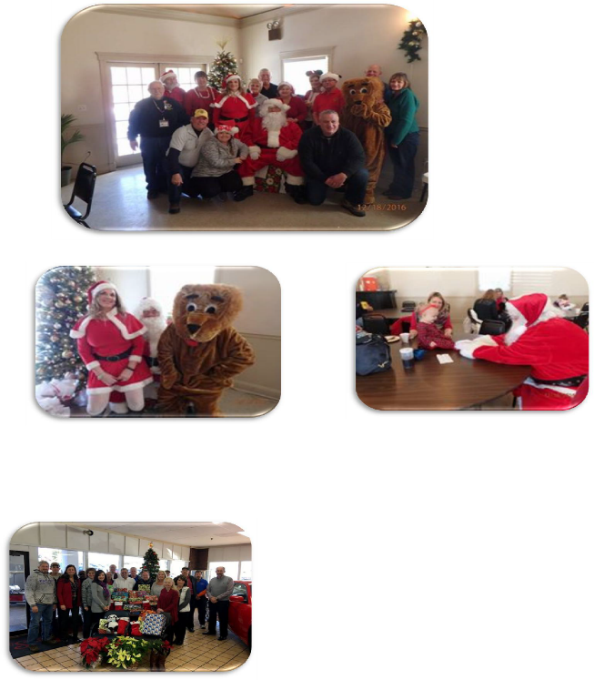
Pacific Lions and Dave Sinclair Chrysler Dodge Jeep Ram'.

For the fourth year in a row, we partnered with the Pacific Adopt-a-Family Program to provide gifts for children in the area. Our employees donated all of these gifts so that a family in need has a very Merry Christmas!

Webster Groves Lions Club - BREAKFAST WITH SANTA

Thanks to all who came to have pancakes with Santa and those Lions who ventured out to cook, serve and cleanup

SLU Lions Club
APR 1st Sat 11AM
St. Louis Public Health Fair
Tegeler Hall
St. Louis University

Pacific Lions
HALL FOR RENT – SEATS 60
BEAUTIFUL GROUNDS FOR OUTSIDE EVENTS & KITCHEN AVAILABLE
GREAT RATES
MEETINGS/SHOWERS $45
PARTIES (3hours or less) $75.00 (4hours or more) $175.00
GRADUATION PARTY SPECIAL $125.00
LOCATION: 319 W MERAMEC PACIFIC
CALL 636-346-4235

DG Jack Link, 2nd VG Duane DeClue, Maplewood Pres. Lion Bunny Maginnis, St, Louis Mid- Town Pres. Lion Bob Berry, Lion June Link, and 1st DG Joe Deter at Maplewood and St, Louis Mid Town Lions for their annual Governor’s Visit.

This was a great evening of information and fellowship.

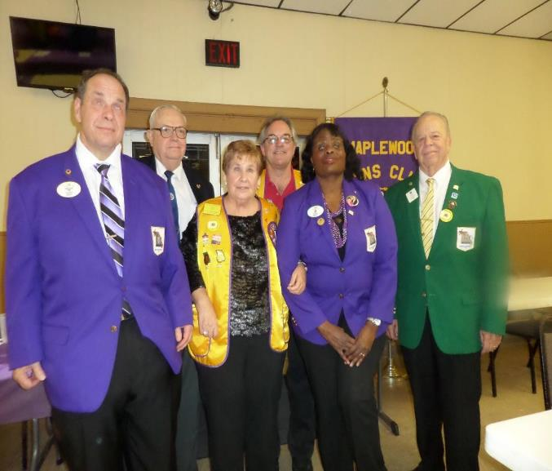
Dear Friend,
For the last 36 years, Operation Food Search has been devoted to serving our community. As we set to begin a new year, let us pause to reflect on our past success and look to the challenges ahead. We are truly grateful for your support and partnership and are delighted to have you share in our work.

Because of your support, in 2016:
• 330 community partners in 32 Missouri and Illinois counties received nutritious food and personal care items through our Emergency Food Distribution program
• 10,720 individuals were educated through our Nutrition Education programs
• 268,570 weekend backpacks kept 9,500 school children nourished during the school year
• 99,824 summer meals were provided to children who otherwise would go hungry. The reality that we face in our work is that there is never enough food to help these families. The need here far, far outstrips the supply.

60 years of continued research confirms the science repeatedly that families who share a meal together, even just 3 times a week, go on to live better lives. They connect, they thrive. Cooking a meal, eating together, cleaning up – something many of us take for granted – is the surest way to begin to build family resilience, which makes our region stronger, healthier, more vibrant.

Our work at Operation Food Search provides meals, along with the skills needed to make them, to struggling families. Your collective kindness and compassionate generosity helps make these meals possible.

As 2016 comes to an end, I want to personally
thank each and every one of you for investing
in our mission. Thanks to your support, we
are healing hunger. Thanks to you, we are
strengthening the future.

Happy New Year!
Sunny L. Schaefer
Executive Director
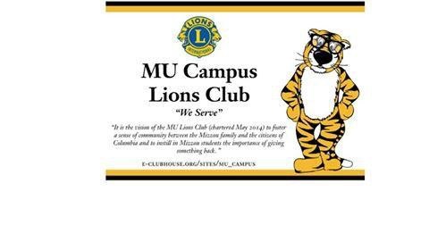
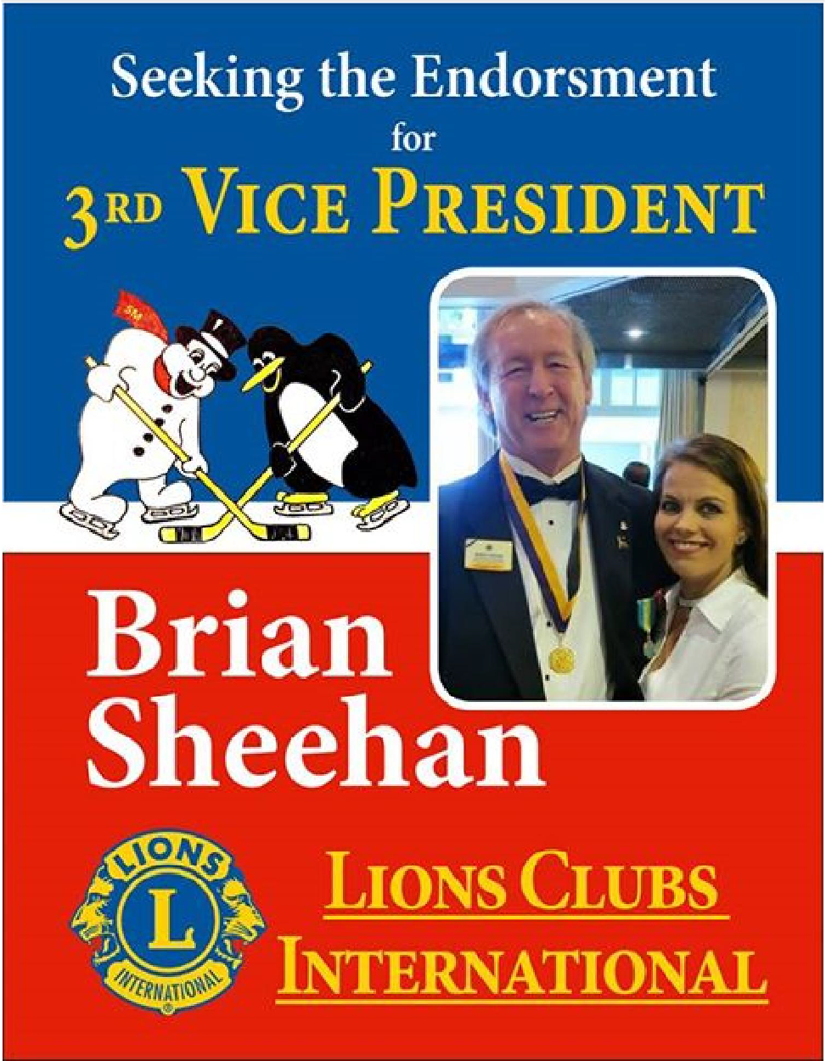
MU Campus Lions Club
April 22nd
Special Olympics Spring Games
Saving Sight

#KidSight #WeSaveSight
Our own 1st VDG Lion Joe Detter
Missouri’s 1st VDGs in Dallas, Texas, training for next year preparing to be our next Governor! A lot of time and dedication goes into this. Thank you 1st VDG’s for what you are doing!

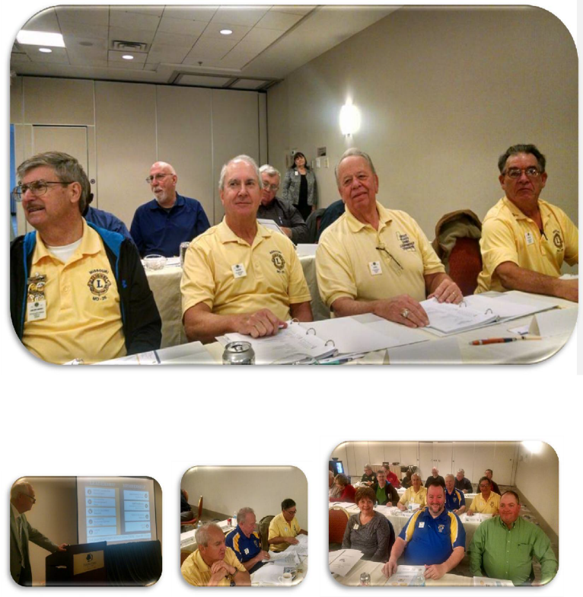
Missouri Lions Training for 1st VDG's!! Here we GO!!

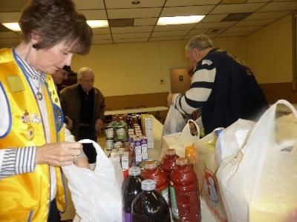
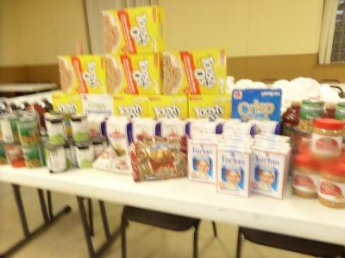

FEED THE HUNGRY

Maplewood Lions collected a large amount of non- perishable food and delivered it to local food pantry. Maplewood Lions regularly collect food for the WOW program at MRH High School. Both food and a monetary donation was made to the food pantry at Immaculate Conception on 1/28/17

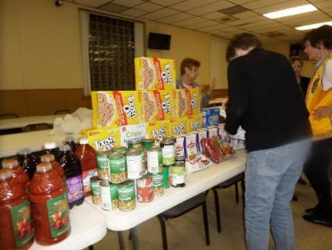

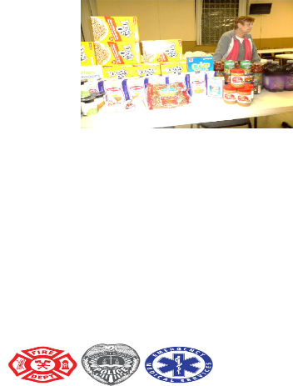



Military & 1st Responders Night Union High School Gym
February 13th
Girls and Boys Basketball Games

All retired and active Military, as well as all police, fire, and EMT personnel, are welcome to Union High School on Monday, February 13th for a basketball double-header featuring our girls and boys basketball teams.
The varsity girls’ tip-off at 5:30 and the boys will start around 7:00. We will recognize all attendees at half-time of the boys’ game, approximately 7:30.
All invitees and their families are welcome to attend free of charge. Just identify yourself at the gate and come in and enjoy some high school basketball.
If you have any questions, please contact Chris Arand, Activities Director, at 636-583-2513 1707.
We look forward for a great evening of basketball and honoring all of our military and first responders.


Lion Jacqueline “Jackie” Hartmann passed away unexpectedly January 13, 2017 from a sudden illness.
Visitation was Tuesday, January 17 from 3-9 pm @ Fey Funeral Home, 4100 Lemay Ferry Rd, St. Louis, MO 63129. Lions Club Rose Ceremony at 7 pm. Jefferson Barracks Lions Club and the Lions of District M2 will miss her dedication and energy.
Lion Jackie was Chairperson of the Youth exchange program for 25 years and kept in touch with most of the youth throughout the years.
Rest in peace Lion Jackie.

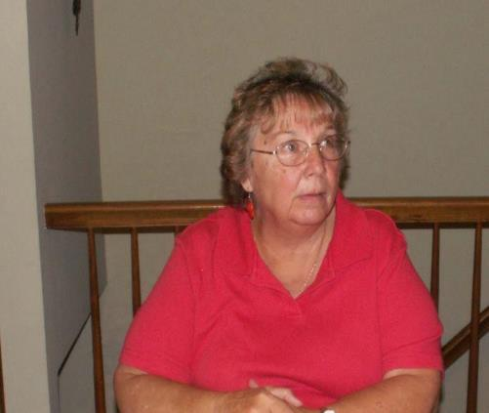
WELCOME
New Members 12/2016 - 01/2017
CUBA LIONS CLUB
DALE L. BLEVINS

HOUSE SPRINGS LIONS CLUB
MICHAEL I BUFFA
SEAN C EHRHART
RICK L EIME
WILLIAM M MAYTAS

MAPLEWOOD LIONS CLUB
JENNIE G. JACO

MEHLVILLE LIONS CLUB
CAROL A. DICKEY
LEE HOWARD

ST LOUIS SOUTHSIDE LIONS CLUB
JOHN J IOVALDI
DIANE G WILSON

VALLEY LIONS CLUB
KIERSTIN BARTON
ANDREW FRIESE
SHANE TINSLEY
ANDREW TURNER

VALLEY PARK LIONS CLUB
LIONEL HALL
CARLA PEELER

WASHINGTON LIONS CLUB
REBECCA S. BUHR
CHAD R. CREGO

WILDWOOD AREA LIONS CLUB
MEGHAN E LEWALLEN

Deceased Members
12/2016 - 01/2017

BRENTWOOD LIONS CLUB
PAUL C BRUEGGESTRASS

CONCORD VILLAGE LIONS CLUB
LYLE J BOUCK JR.

MAPLEWOOD LIONS CLUB
MARK E GILLAM

WASHINGTON LIONS CLUB
DONALD R BOWERS
JOHN L POLITTE

Maplewood Lions visited the residents of the Mary Culver Home Feb. 12th and enjoyed a social time with them. Ice Cream and cookies were served and each resident was presented with a Valentine gift of slipper socks. Lion Gary entertained everyone with many gospel hymns.
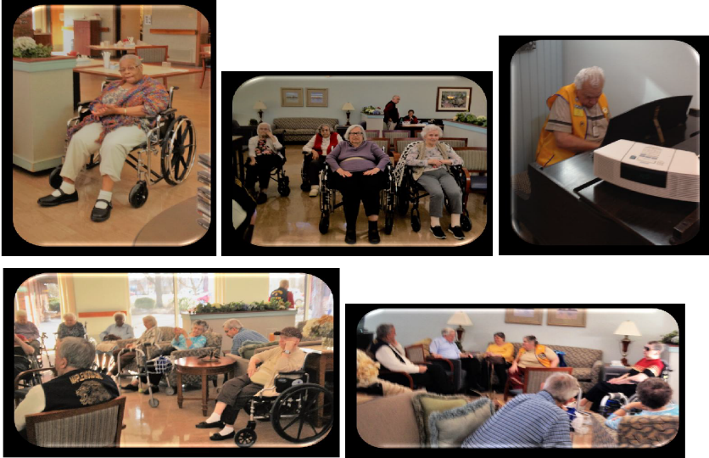
MindsEye is a nonprofit doing something very interesting for the visually impaired. Check out their upcoming fundraiser, Soirée pour la Vue - An Evening for Sight.

Harris Heroes: Radio stations keeps visually impaired 'a part' of community

Most often used for music, a former police officer uses the radio as a way to learn about what is going on around him.


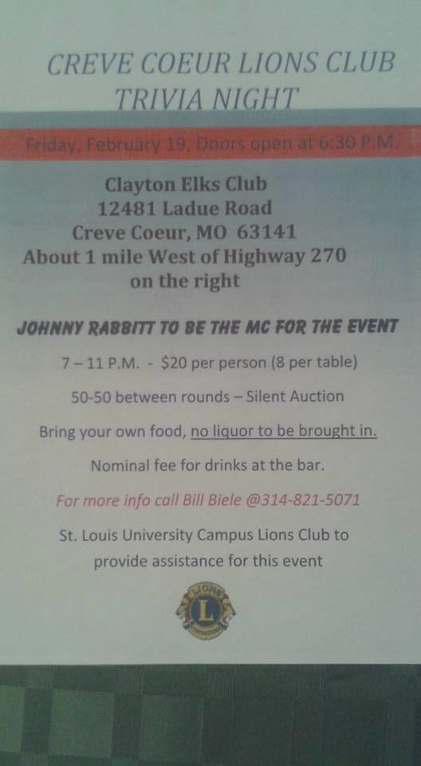
lewo od
The Lions Roar Show was started as a variety charity show circa 1946, with this year being our 70th show! It has usually been the largest yearly fundraiser we hold, and the “profits” always go to the charities we support – which
are many.

Come to our charity show - it's silly and a LOT of fun! Or take out an ad in our show book to help us support the blind, teenage suicide prevention, Ranken Jordan Center, the USO, the Salvation Army, and so many more.

When
you help, WE SERVE!

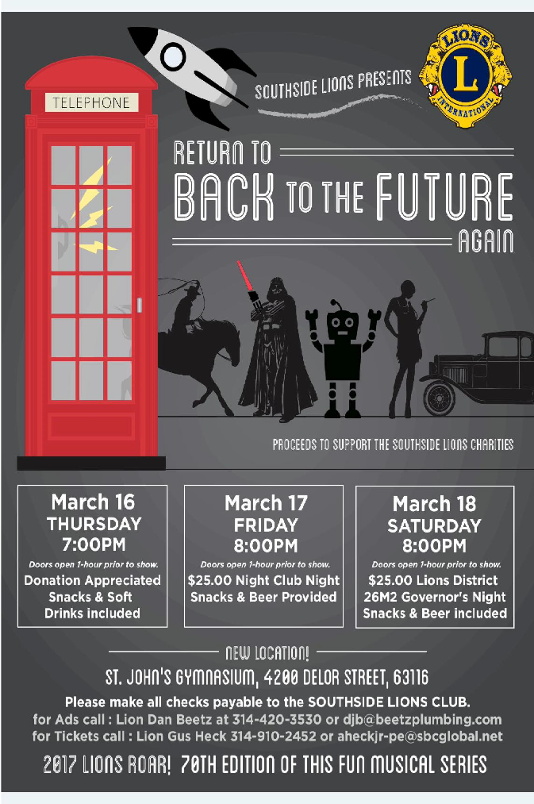
SOUTH SIDE LIONS ROAR
Protect Our Planet this April
A healthy planet starts with healthy communities. This April 17–23, join international President Chancellor Bob Corlew and Lions around the world for a special Worldwide Week of Service dedicated to protecting our planet and the environment in your community. From cleaning up a park to planting trees in your neighborhood, there are countless ways to join the Worldwide Week of Service to Protect Our Plant. To learn more about how your club can serve, visit Worldwide Week of Service webpage to start planning your service project today!



Dear Lion,
The Centennial year has finally arrived! And we're celebrating it in a big way with the Centennial issue of LION Magazine. Read it now on your smartphone, tablet or computer.
Take a look at some Centennial highlights and digital exclusives:

Check out more than 20 special videos and hear historic audio of our founder, Melvin Jones.

Discover 100 years of history, including how Lions stepped up to help after the 9/11 attacks in Clubs.

Discover how Lions are planning to meet the second century of service in Service. Wherever you go, LION Magazine is already there on your mobile device. Enjoy the first century of Lions...read the Centennial issue right now!

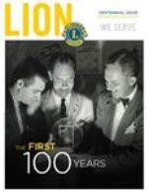
INTERNATIONAL ASSOCIATION OF LIONS CLUBS
Missouri Lions District 26-M2
2017 Convention Committee

As the 9th annual District M2 Convention quickly approaches, now is the time to make your plans to be there and participate in the weekend events. The Convention will be March 24th thru March 26th 2017.

The ENTIRE Convention will be held at the Doubletree Hotel St. Louis at Westport. The Friday night Hospitality will be held in the Grand Ballroom. We will be able to accommodate lots of Clubs' hospitality booths in one large area, including entertainment and a dance floor with lots of room for socializing with Lions and friends.

The cost to your Club to have a hospitality booth this year will be
$185.00. This will include hospitality booth/ tab les (approx. l 6' x8', 3
- 8 foot tables, ice service, trash service and chairs.

Please submit your reservations and special request as soon as possible. Please make your payments payable to: District 26-M2 Convention Fund and mailed to CC Joe Foster, 167 St. Johns ER Church Road, Leslie, MO 63056. The Convention Committee will then assign all hospitality spaces.

As in th e past, we strongly encourage the Clubs that are participating to provide food and beverages to share. To help offset the expense of this event, you will be allowed to conduct a fundraiser.


LIONS FELLOWSHIP NIGHT FEB. 11TH HOLIDAY INN SIX FLAGS
We had great night of fellow ship and fun.

THE YELLOW HAT BRIGADE
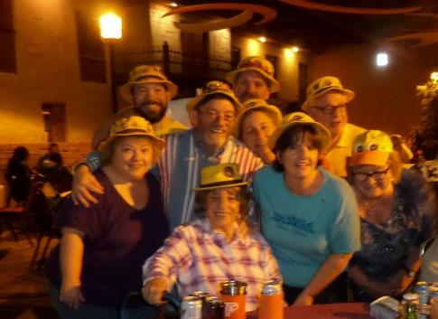
Calling all LIONS!

District 26-M2 Annual Convention will be held on March 24-26, 2017. There will many exciting changes to this year’s District Convention.
The Convention will be held at the Doubletree Hotel St. Louis at Westport Plaza. This is where all the Saturday business meetings, luncheon, voting, banquet and Sunday memorial service will be held.

The Hospitality night will be on Friday night also at the Doubletree Hotel St. Louis at Westport Plaza. This is a fabulous facility that will be able to hold lots of Clubs’ hospitality booths, and includes a large dance floor with lots of room for socializing with Lions and friends.

The Doubletree Hotel St. Louis at Westport, 1973 Craigshire, St. Louis, MO 63146 is holding a block of rooms and taking reservations at a discounted price of $89 + tax for a standard room.

Please contact them directly at (314) 434-0100 to make your room reservations at the Doubletree Hotel and mention that you are with the District 26-M2 Lions Convention or book online at http://doubletree3.hilton.com/en/index.html group code CLB.

After MARCH 4, 2017 the room block will be released and the discounted price will no longer be available.

You can find more information on our website www.lions26m2.org.

The Doubletree Hotel is looking forward to hosting the Lions in March, and the committee is looking forward to seeing everyone there for a great weekend!! So, don't hesitate any longer, send in your registration now, make your hotel arrangements soon and plan on having a fun time!! And don't forget to share this information with all your Club members!!

Make your plans now so that you don’t miss any of the fun and fellowship. 2017 District 26-M2 Convention Committee
PCC Gina Boettcher – lionbtkr@gmail.com
CC Joe Foster - jmcdf4@hughes.net

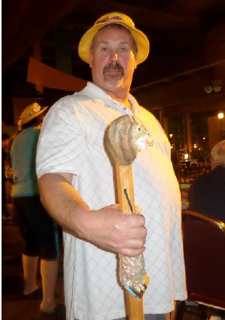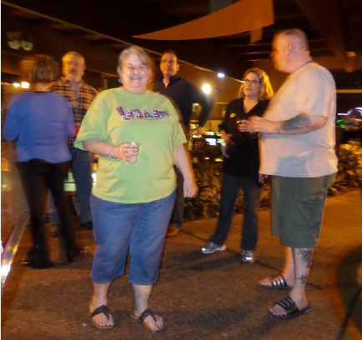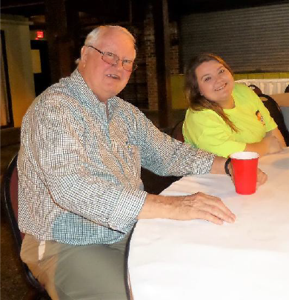
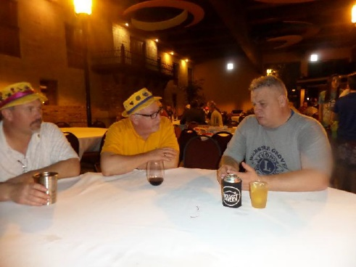
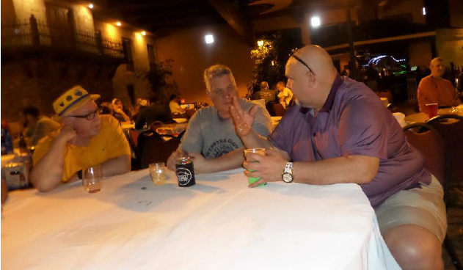
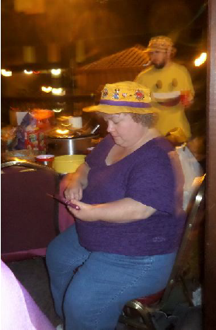
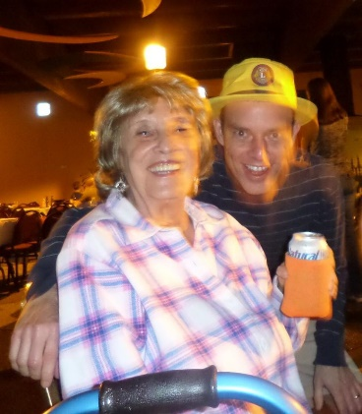
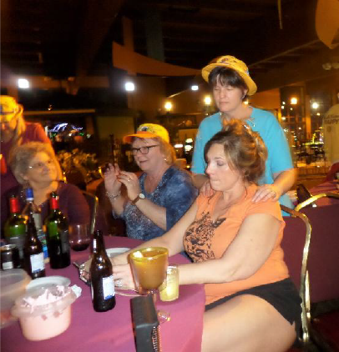
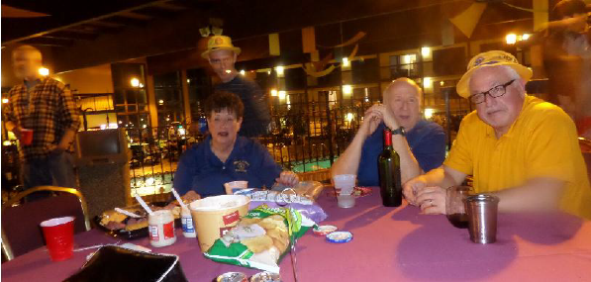
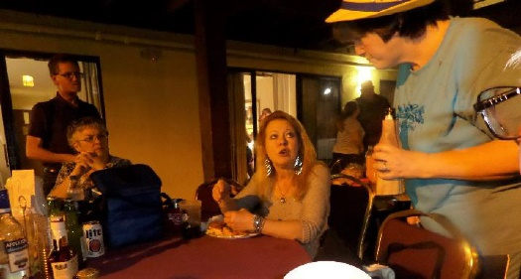

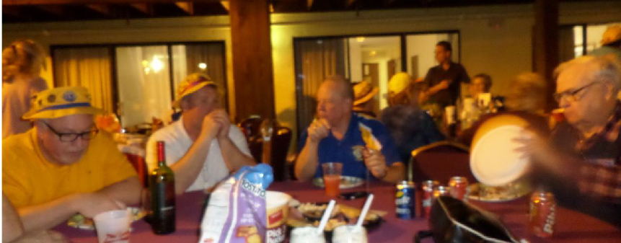

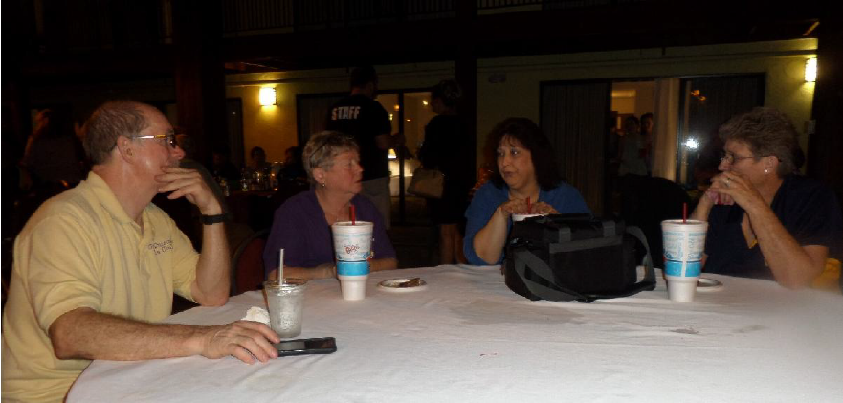
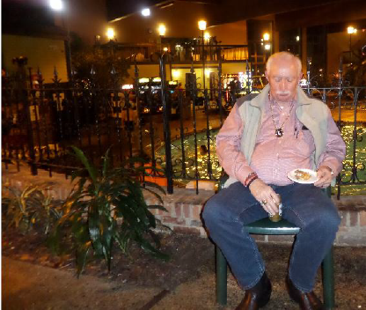
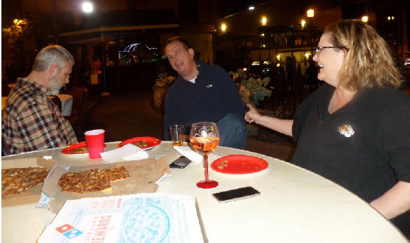
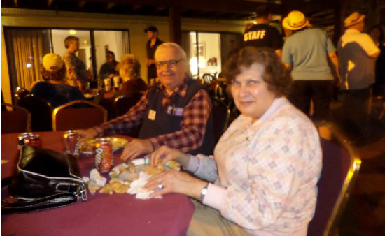
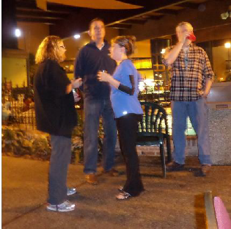
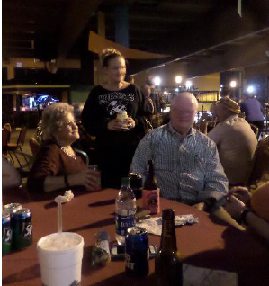

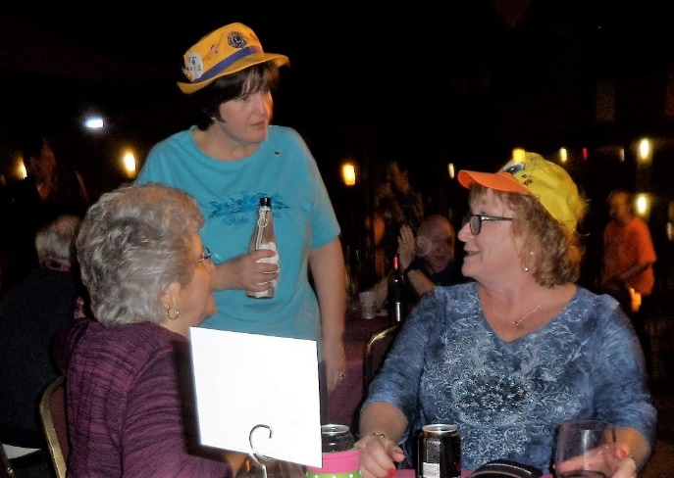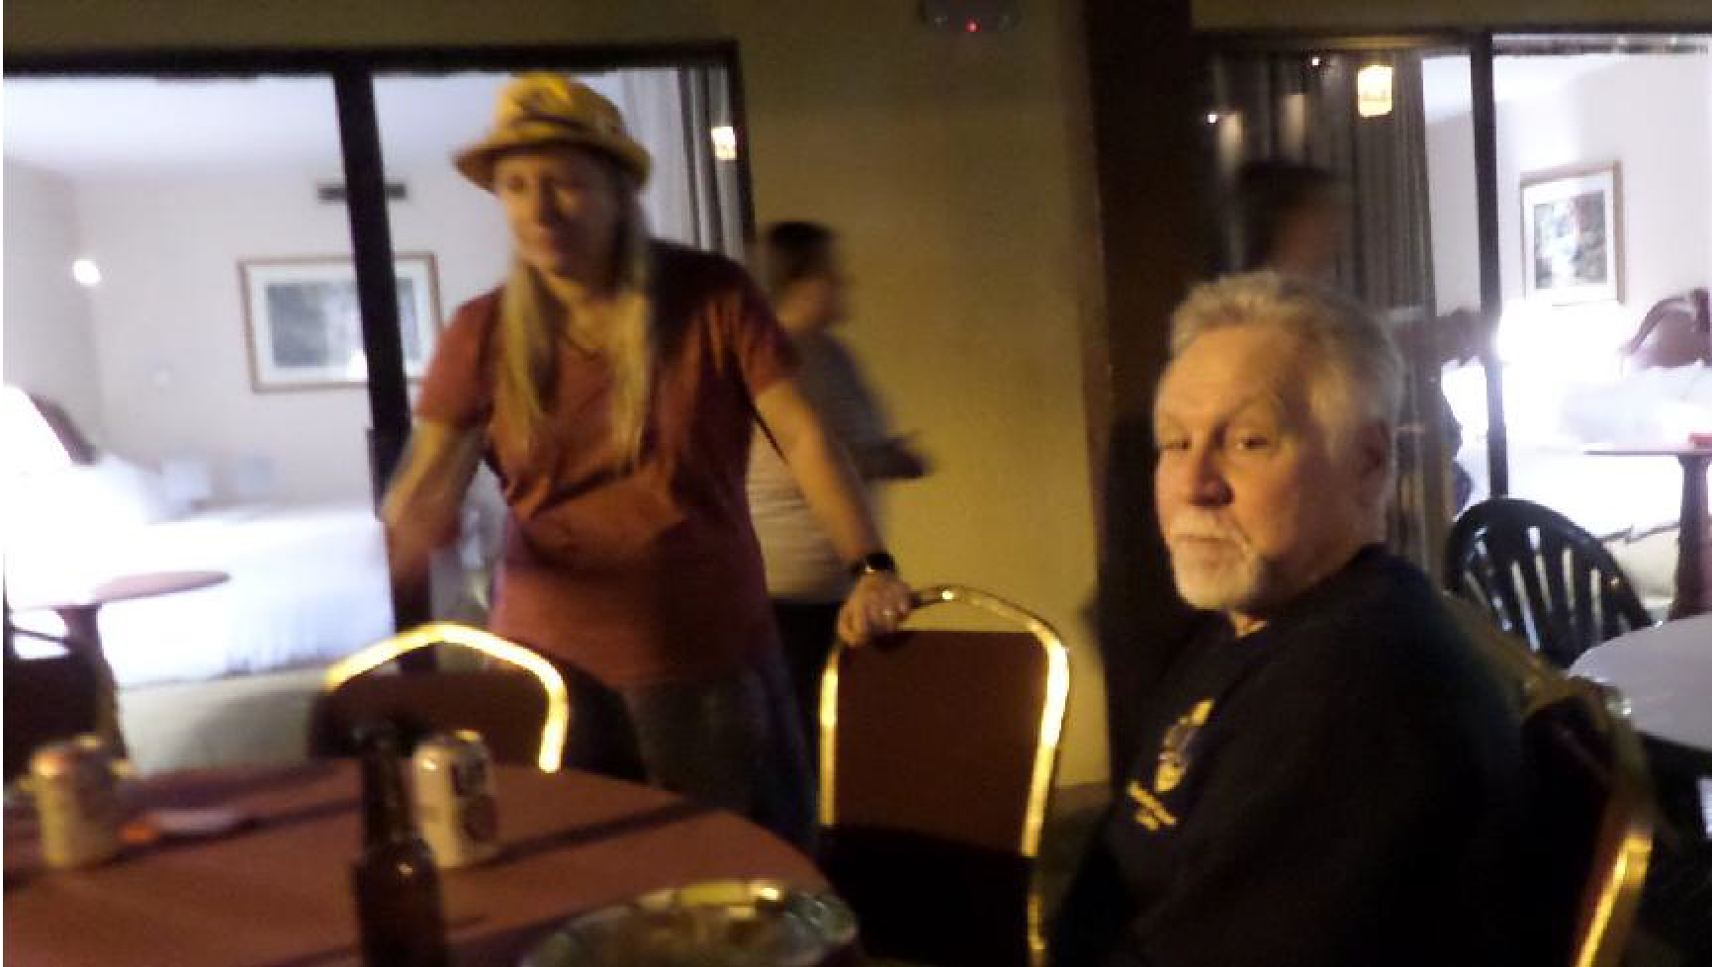

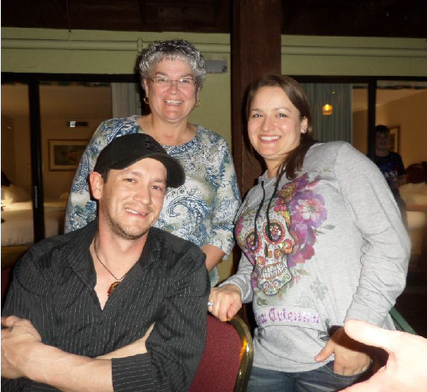
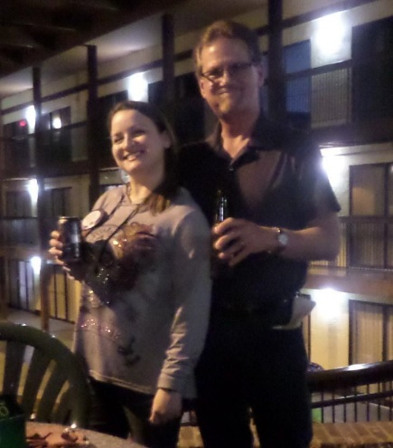
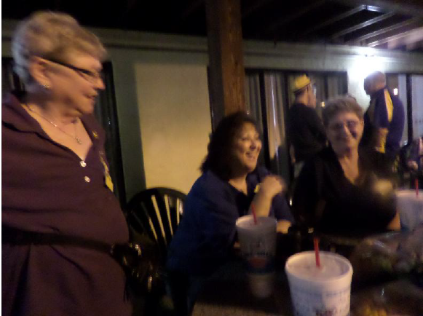
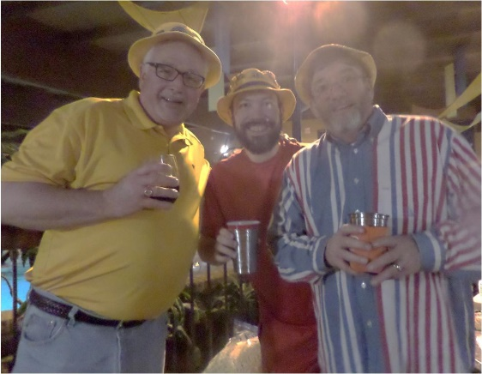

DON’T MISS THIS FUN Night
JOIN US NEXT YEAR

Four of MSB’s students participated in the Special Olympics Bowling Tournament at Brunswick Lanes on January 19th. Each student had a helper from Ladue Middle School to assist them in their bowling skills. Alison Miller received a gold medal and Ali Lyon, Kiwan Sanders, and Sirria Brooks all received silver medals. We are all very proud of you guys and Go Mules!
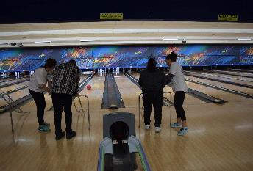
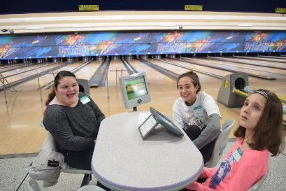
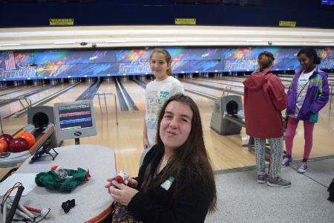
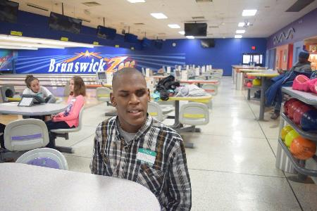
TAKE YOUR SWEETIE TO THE FORUM

for an unbelievable weekend of learning at the Forum & to explore on the most exciting cities in the United States.

September 21 – 23, 2017
Portland, Oregon

Save the Date!
The 25th Annual Run for Sight
will be Sunday, May 7, 2017,
at Ballpark Village.

Registration coming soon!

Visit www.dgcrunforsight.org for updates and information.
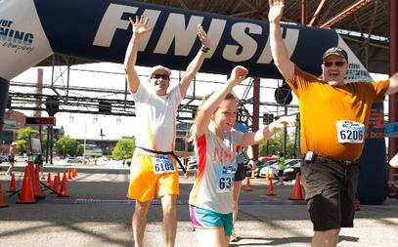


MAPLEWOOD LIONS CLUB PRESENTS THEIR THIRD ANNUAL “V I P GOT TALENT”
(a talent contest for visually impaired & legally blind persons only)
Saturday afternoon March 11th, 2017 - from 2:00 until 5:00 – with short intermission
At Missouri School for the Blind
Multi-Purpose (annex) Building
3867 Magnolia Avenue, St. Louis, MO 63110 All talent welcomed - individuals - teams - groups
Singers – musicians - dancers - comedians - jugglers (no chain saws please)

1st place prize | $150
2nd place prize | $100
3rd place prize | $50
Applications available by contacting Lion Verneal Barlow, vernealbarlow@sbcglobal.net or 647-0347 - before February 28th, 2017
(contestants accepted on a first come-first serve basis - by date applications received)
(if more applications are received than time period allows - applicants will be asked if they are willing to come and fill in if time allows or another performer is unable to attend)
AUDIENCE ADMISSION $5.00 - INCLUDES CHANCE FOR DOOR PRIZE SNACKS AND DRINKS AVAILABLE FOR PURCHASE
SILENT AUCTION AND RAFFLE ITEMS AVAILABLE








February 2017

- 11th, Saturday: District Fellowship Night
@ Holiday Inn Six Flags, 4901 Six Flags Rd, Eureka, MO 63025. Call for LIONS rate (636) 938-6661. Social starts down by the pool around 4pm until? Bring a snack to share and your own beverage to enjoy. INSIDE Swimming pool is open!!

* 18th, Saturday: Mouse Races and Silent Auction hosted by the Wildwood Area Lions Club (& West St. Louis County Rotary) @ St. John Lutheran, 15800 Manchester Rd., Ellisville, 63011. Doors open at 6pm; races start at 7pm. $15 per person. Contact Lion Sandee Marshall (636-394-0659) for tickets or to reserve a table of 10.

21st, Tuesday: District Governor's Visit with Kirkwood Lions Club

*25th, Saturday: St. Louis Mid-Town Lions Chili Dinner. Contact Lion Tom Culliton for more information mousaba@sbcglobal.net.

*26th, Sunday: Pacific Lions Club 65th Annual Pancake Breakfast @ Pacific Senior Center, 800 West Union, Pacific, MO. 7:30 a.m. -- 12:00 p.m. Pancakes, Sausage, Eggs, Juice, Milk & Coffee Adults $8.00 -- Kids
$4.00.

28th, Tuesday: DG Visit with Washington Lions Club.

March 2017

3rd – 4th, Friday – Saturday: Mid-South Quarterly meeting at the Hamilton Eye Institute, Memphis, TN

6th, Monday: District 26-M2 G-Force meeting @ Mike Duffy’s, Kirkwood, MO.

7th, Tuesday: DG Visit with Valley Park Lions Club.

11th, Saturday: 3rd annual Maplewood Lions Club VIP (visually impaired person) Talent Contest from 1 to 4 o'clock in the afternoon at the Multi-purpose building at the Missouri School for the Blind. If you have any questions, contact Lion Verneal Barlow at
314-647-0347 or
veronicasmith5800@gmail.com

24th – 26th, Friday- Sunday: 9th Annual District 26-M2 Convention @ Doubletree Hotel St. Louis at Westport, 1973 Craigshire Rd, St. Louis, MO 63146. For more information: http://www.lions26m2.org/convention.html

April 2017

3rd, Monday: District 26-M2 G-Force meeting @ Mike Duffy’s, Kirkwood, MO.

* 7th – 8th: Friday – Saturday: Mid-South Lion Leaders Weekend, Hamilton Eye Institute, Memphis, TN. Starts Friday at 5 PM until Saturday at 3 PM. Registration information at www.midsouthlions.org.

*8th, Saturday: Mid-Town Lions/MO Association of Blind Athletes Trivia. Contact

Lion Tom Culliton for more information mousaba@sbcglobal.net.

May 2017

1st, Monday: District 26-M2 Cabinet meeting.

June 2017

2nd – 3rd, Friday – Saturday: Mid-South Annual Meeting (and possibly auction) at Hamilton Eye Institute, Memphis, TN

5th, Monday: District 26-M2 Cabinet 1th, Sunday meeting.

1: House Springs Lions Club Motorcycle Ride for Kids Sight.

OTHER GENERAL ANNOUNCEMENTS:

The District 26-M2 Eye Care Committee meetings are normally held on the 3rd Monday of each month at Fey Funeral Home, 4100 Lemay Ferry Rd, St. Louis, MO 63129. Starts at 7:00 pm.

The District 26-M2 Eye Foundation meetings are normally held on the 3rd Monday of each month at JB Smith Funeral Chapel, 777 Oakwood Dr., Fenton, MO 63026. Starts at 7:00 pm.

Valley Lions Club has Music Jamboree on the second Saturday of every month (starting Oct 11th). 7:00 pm @ the club house on Highway C in Belgrade. Bring your instruments and join in the fun. Food available.

Beaufort Lions Club has BINGO every Friday night. Beaufort Lions Hall, 2041 Lutheran Church Rd., Beaufort, MO 63013. Early bird starts @ 6:30, regular games start
@ 7:00 pm
House Springs Lions will be holding a Texas Holdem every Thursday at the House Springs Lions Hall. Doors open at 6pm game starts at 6:30, $40 buy in, snacks and drinks available.

Valley Park Lions Club has Texas Hold~em. 1st & 3rd Fridays of each month. Sign in 6:00 pm. Games Start 7:00 pm. $20.00 Buy in
$5.00 Bounty Optional. Location: Valley Park Lion’s Den 1001 St. Louis Avenue Valley Park, Mo. 63088. Information Call: Lion Bobbie Sue 314-327-4199 or Lion Matt 314- 255-3354

Valley Park Lions Club has All You Can Eat Breakfast on the 3rd Sunday of each month. 8:00 am. to 11:00 am. Adults $8.00 Kids $5.00(8yrs.& under) Breakfast Items Include: Scrambled Eggs, Sausage Patties, Pancakes, Bacon, Biscuits & Gravy, French Toast, Orange Juice, Coffee& Milk. Location: Valley Park Lion’s Den 1001 St. Louis Avenue Valley Park, Mo. 63088. Information Call: Lion Kaye 314-698-0700.

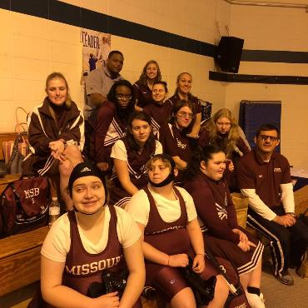
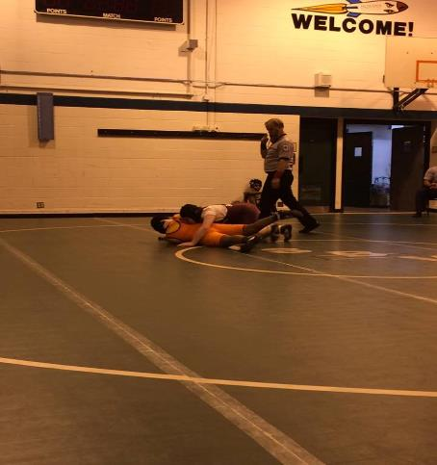
Missouri School for the Blind at Indiana School for the Blind and Visually Impaired are ready to wrestle! #Go Mules #LoveMyMSB

Beaufort Lion's Club presents a
Paint & Sip

Come enjoy an evening with friends and paint your own masterpiece! No experience needed, just come have fun!
When: Saturday, March 11, 2017 Time: 5pm-9pm
Where: Beaufort Lions Club
2041 Lutheran Church Rd, Beaufort MO
$35 Per Ticket includes one drink
All Supplies provided- will paint a 10x13 canvas each

*RSVP to Tasha 314-750-6280 or Jane 636-584-9529* Please register by February 18, 2017
Will have food and drinks available for purchase. (non-alcoholic and alcoholic beverages)

